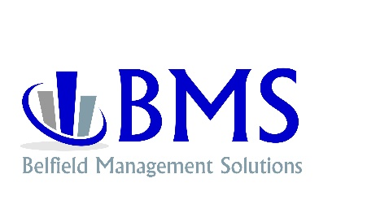

Why Belfield Management Solutions?

BMS INC. was founded in 2019 for the purposes of providing business impact solutions. In the business consulting world, 2 large companies controlled 90% of the business consulting projects. Both companies provided recommendation-based consulting services.

Recommendation based consulting is the model where one or more consultants come into the business. They create a program to “fix” the business and then hand the business owner with a notebook on how to fix his/her business. If the business owner had the time or knew how to “fix his/her business, they wouldn’t need a consulting firm in the first place. This model drains company cash flow and the owner does not get the help that was needed in the first place.

By practicing business impact solutions, the consultant creates the implementation him/herself to ensure the project moves forward and while the implementation is in effect, the consultant teaches the client and his/her staff how to manage the project. This is one and only one consultant in the business at any given time.

In recommendation consulting, the consultants, normally 2-3 consultants write out how to implement the project and proved the business owner the steps in how to implement the project. The client is being billed per man hour. For example: If 2 consultants work a 40-hour week and $450 per hour, the client is being billed at $900 per hour times 40 hours which is $36,000. The consultants burn through the client’s cash and the project does not run the specified amount of time. If the client had time or new how to implement the project, the client would not need a consultant in the first place.

With Business Impact Solutions, the consultant implements the project(s) and teaches the owner, management, and staff how to manage the project after it is implemented. There is only 1 consultant billing at a flat fixed monthly rate. This is a much smaller impact on the client’s cash flow. Because of these reasons, the jobs run to completion and the client gets the cost savings and the additional net profits he/she was promised.

This is how BMS INC. has been in business with 0 complaints from our clients and we have successfully completed over 9,600 projects. BMS INC. is the only company to achieve and maintain this rate of success.

The business model at BMS LLC. is founded by Christian ethics and professionalism. The Business Impact solutions we provide is dependent on the quality and experience of the Senior Business Consultant.

